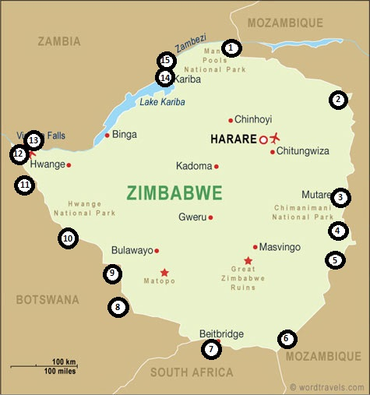

- Kanyemba 06:00 – 16:00
- Nyampanda / Cochemane 06:00 – 18:00 0722838
- Machipanda / Mutare 06:00 – 18:00 02063003/67532
- Rotunda / Cashel 06:00 – 18:00 (pedestrians only)
- Mt Selinda / Espungabera 06:00 – 18:00 0274511/2
- Sango / Chicualacuala 06:00 – 18:00 0312505/2836/2866
- Beitbridge 24 hours 028622529
- Matsiloje / Mphoengs 06:00 – 18:00 0192561/4
- Ramokgwebana / Plum Tree 07:00 – 20:00 0192561/4
- Maitengwe 06:00 – 18:00 0192561/4
- Pandamatenga 08:00 – 18:00 01345876/540876/43436
- Kazungula Road 06:00 – 18:00 01342330
- Victoria Falls 06:00 – 22:00 01345876/540876/43436
- Kariba 06:00 – 18:00 0612355/3447/9/3500
- Chirundu 06:00 – 18:00 0637616/660/662

