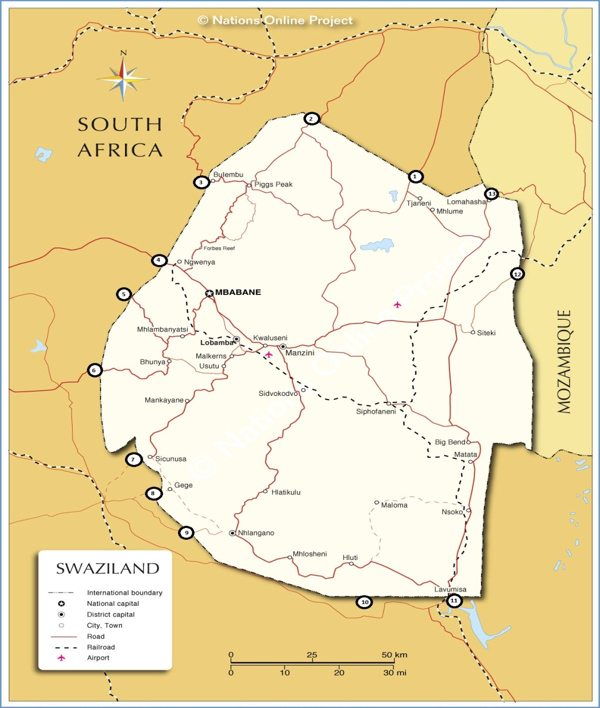

- Mananga 07:00 – 18:00 0137907167
- Matsamo / Jeppe’s Reef 07:00 – 20:00 0137810384
- Bulembu / Josefsdal 08:00 – 16:00 0137123891
- Ngwenya / Oshoek 07:00 – 22:00 0178820001
- Lundzi / Waverley 08:00 – 16:00 0178193481
- Sandlane / Nersten 08:00 – 18:00 0178469207
- Sicunusa / Houtkop 08:00 – 18:00 0178250941
- Gege / Bothashoop 07:00 – 20:00 0178250400
- Mahamba 07:00 – 20:00 0178250076
- Salitje / Onverwaldt 08:00 – 16:00 03344131380
- Lavumisa / Gollela 07:00 – 22:00 03344351070
- Mhlumeni / Goba 24 hours 0026823436021
- Lomahasha / Namaacha 07:00 – 20:00 0025821960090

