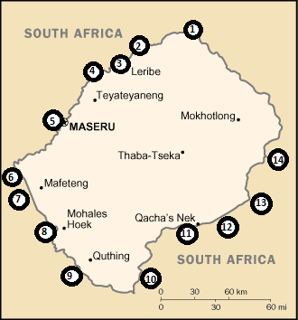

- Monantsa Pass 08:00 – 16:00 0587131600
- Caledonspoort 06:00 – 22:00 0582238400
- Ficksburg Bridge 24 hours 0519332760
- Peka Bridge 08:00 – 16:00 0519333951
- Maseru Bridge 24 hours 0519244300
- Van Rooyens Gate 06:00 – 22:00 0515831525
- Sephaphos Gate 08:00 – 16:00 0337021169
- Makhaleng Bridge 08:00 – 16:00 0516731484
- Tele Bridge 06:00 – 22:00 0516111710
- Ongeluksnek 08:00 – 16:00 0392567001
- Qacha’s Nek 06:00 – 22:00 0392564391
- Ramatsilitso Gate 08:00 – 16:00 0362564443
- Nkokoana Gate 08:00 – 16:00 0337011212
- Sani Pass 08:00 – 16:00 0337021169

